Phase 1: Building an Action Team

Invite potential action team members
To develop a dementia friendly community, every part of the community will need to be represented. Use the Action Team wheel to identify a wide range of stakeholders, local opinion leaders, and technical experts who can help champion a vision, engage the community, set priorities, and act together.

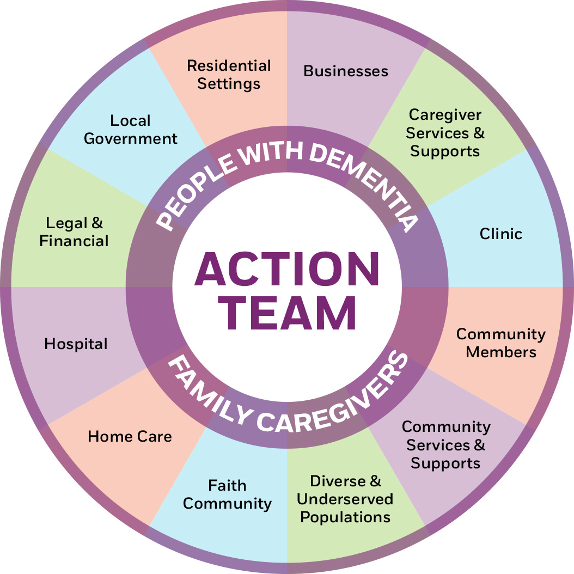
Many parts of your community have a formal or informal stake in ensuring that the community is prepared to support people with dementia or have a concern for the community’s health and viability.

The most important team members are people who have had personal experience with dementia, including people with dementia and their caregivers. People who have had friends, family, and neighbors with dementia will have a good understanding of where community supports exist and where they are lacking or missing altogether. Reach these people through the Alzheimer’s Association, dementia and caregiver support groups, faith communities, and long term care facilities.

Others may include:

- Health care community: adult day programs; ambulance service/emergency medical technicians; hospitals; clinics; home health agencies; hospice programs; mental health clinics; pharmacies; dental, vision, and hearing professionals; chiropractors, and community health workers
- Educational institutions: colleges and universities in your community with health care programs
- Government agencies/departments: city council, community planning and development; health services, social services, city/county inspection offices, police/sheriff, fire, motor vehicle; transportation; housing
- Nonprofits or faith-based organizations that serve seniors and/or people with disabilities: Alzheimer’s Association, AARP, Meals on Wheels, Catholic Charities, senior companion programs
- Residential settings: single family and congregate residences, independent apartments, assisted living, respite care, and nursing homes
- Senior service providers: senior centers, Area Agency on Aging, independence at home services (chores, home safety, meal delivery)
- Businesses: Banks, business associations, chambers of commerce, employers/human resources, retail, restaurants, realtors, insurance agents, barber shops/hair salons, grocery stores, post office, landlords
- Charitable or fraternal organizations/community service clubs: Kiwanis, Knights of Columbus, Lions, Rotary International, Fraternal Order of Eagles, Optimist Club, Elks Club, veteran service organizations, youth groups
- Diverse and underserved populations: Ethnic, racial, cultural, and linguistic organizations; organizations serving low income populations
- Advanced planning industry: Financial, legal, and advanced care planning professionals
- Faith leaders: ministerial association, churches, synagogues, mosques, temples, other houses of worship, congregational groups , parish nurses
- Wellness programs: fitness centers, YMCA, YWCA, farmers markets and others
- Community engagement organizations: art or music organizations, museums, libraries, intergenerational opportunities with schools Pre K-12, parks and recreation, organizations that facilitate connections with animals, outdoors, nature

